WATLINGTON PARISH COUNCIL

Parish Chairman, Mrs Jean Golding
25 Fen Road, Watlington,
King’s Lynn, Norfolk, PE33 0JA
01553 811362

Parish Clerk, Mrs Sara D Porter
The Old School House, High Street,
Stoke Ferry, King’s Lynn, Norfolk, PE33 9SF
01366 502165
watlingtonparish@hotmail.co.uk

watlington.norfolkparishes.gov.uk

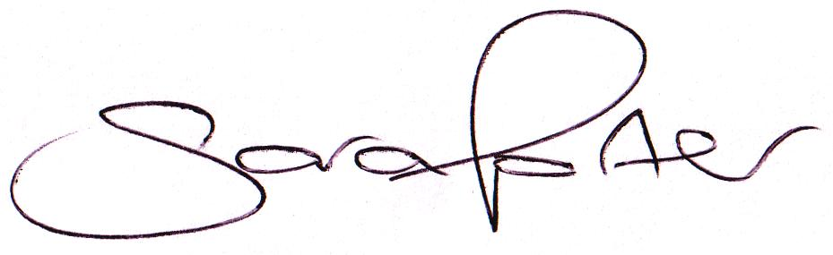Councillors are hereby summoned to attend a Full Council meeting of Watlington Parish Council on Thursday, 10th September 2015 at 7.00pm in the Jubilee Room, Watlington Village Hall, Watlington, for the purpose of transacting the business on the agenda shown below.

Sara Porter (Mrs)
Parish Clerk
2nd September 2015

The meeting is open to the press and public
AGENDA
1. To receive and accept apologies and reasons for absence
2. To approve the minutes of the previous Council meeting held on Thursday, 30th July 2015 (Items 80/15 - 91/15)
3. Councillor issues – Vacancies
3.1. Co-option of applicants: Ms Alexandra King and Mrs Emma Simmonds
4. To receive declarations of interest for items on the agenda and any requests for dispensation
TO ADJOURN THE MEETING IN ORDER TO ALLOW THE PRESS AND/OR MEMBERS OF THE PUBLIC TO ADDRESS THE COUNCIL IN A PUBLIC OPEN FORUM (MAXIMUM 20 MINUTES – 3 MINUTES PER SPEAKER)
6. To receive reports
6.1. County Cllr Brian Long
6.2. Borough Cllr Peter Hodson
7. To receive Finances and Clerk’s Report
7.1. Clerk’s financial report
7.2. Payment authorisation – the Council is invited to view pre-authorised payments and approve pending payments listed below. Any payment requests received after publication of the agenda will be reported at the meeting.
Payee | Amount | Authority | Description | Date Paid
PAYMENTS
BCKL&WN | £45.00 | WPC | Fees for Office address
Broker Network (Came & Company) | £1534.12 | WPC | Annual Insurance | 30.07.2015
E-On | £706.27 | Admin | Street Lighting Charges Apr-Jun | 01.08.2015
Watlington Village Hall | £15.00 | Admin | Meeting Room Fees | 17.08.2015
Ultimate Land & Gardens | £373.80 | Admin | Grounds Maintenance x 2 Visits | 17.08.2015
K & M Lighting | £151.06 | Admin | Street Lighting Maintenance Aug | 17.08.2015
K & M Lighting | £875.00 | WPC | Street Lighting Electrical Testing | 17.08.2015
Norfolk Association of Local Councils | £24.50 | WPC | Donation | 17.08.2015
Johnston Publishing Ltd | £257.64 | Admin | Parish Clerk Vacancy Advertisement | 02.09.2015
Ultimate Land & Gardens Ltd | £186.90 | Admin | Fortnightly Grounds Maintenance | 02.09.2015
Hayes & Storr Solicitors | £883.00 | Admin | Glebe Land Completion Fees | 02.09.2015
Sherril Dixon | £791.81 | Admin | Clerk Salary Aug | 02.09.2015
Sara Porter | £904.63 | Admin | Clerk Salary Jul & Aug | 02.09.2015
Sara Porter | £135.01 | Admin | Clerk Expenses Jul & Aug | 02.09.2015
Sherry Grief | £82.50 | Admin | Litter Picking Services Aug | 02.09.2015
K & M Lighting | £151.06 | Admin | Street Lighting Maintenance Sep | 02.09.2015
RECEIPTS
Village Fete | £600.00 | WPC | Donation (Earmarked MUGA) | 06.08.2015
7.3. To approve a bracket replacement for Street Lighting Unit 9016, Thieves Bridge Road – Cost £135.00 + VAT
7.4. To consider Norfolk Association of Local Councils Introductory Training for Clerks and Councillors
7.5. To consider and approve the Clerk submitting the General Power of Competence unit to the Society of Local Council Clerks – Cost £30.00 (Re-sits additional £30.00) – Chairman to report
7.6. To consider the services of the Community Payback Team to clear the dyke in Fairfield Lane – Chairman to report
7.7. To consider upgrading the size of the Glazewing waste collection unit at the Village Hall – Vice Chairman to report
7.8. To discuss the Clerks’ hours
7.9. To consider requests for Grants and Donations (2015/2016 Budget remaining £676.90)
7.9.1. East Anglia's Children's Hospices (EACH)
7.9.2. The Norfolk Hospice Tapping House
8. To receive Correspondence
8.1. For action
East Anglia’s Children’s Hospices (EACH) | Donation Request | 13.08.2015
The Norfolk Hospice Tapping House | Donation Request | 24.08.2015
8.2. For information
9. To receive reports/updates on the Recreation Ground/Open Spaces and consider and approve any actions required
9.1. Byelaws and use of open spaces – Update by Vice Chairman
9.1.1. Establish ownership of parcel of land at the Stone Close Play Area
9.1.2. Consideration of extending the fences at the Stone Close Play Area
9.2. Community Projects Panel – MUGA project – Update by Chairman
9.3. Handyman – Update by Clerk
10. To receive reports/updates on Community Matters and consider and approve any actions required
10.1. Village Hall – Update by Vice Chairman
10.2. Village Hall Office – Report by Vice Chairman – approval required for:
10.2.1. Lease Agreement
10.2.2. Set up costs (post box, handyman installation costs, signage)
10.2.3. Agreement to pay the Village Hall for the phone line until it is transferred to the Council
10.2.4. Consider and approve continuing the provision of the BCKL&WN Community Information Point
10.3. Allotments – Update by Chairman
11. To receive reports/updates on Highways & Transport Matters and consider and approve any actions required
11.1. Parish Partnership – 2015 Trod bid – Update by Clerk
12. To consider Planning Applications and note Planning Decisions from the BCKL&WN
12.1. Planning Applications for consultation:
12.1.1. 15/01243/O – 35 School Road – Outline application with some matters reserved for residential development with access
12.1.2. 15/01306/OM – Storage Land – Outline application with some matters reserved for mixed use development comprising 50 no. space car park, 500sq m of B1 use and 9 no. dwellings
12.2 Planning Decisions received for information:
12.2.1. 15/01100/PAGPD – 1 Nene Road – Single storey rear extension which extends beyond the rear wall by 5 metres with a maximum height of 3 metres and a height of 2 metres to the eaves – Approved under delegated officer powers
12.2.2. 14/01227/OM – Storage Land, Station Road – Outline application for mixed use development including 50 space station car park, 500 square metres for Class B1 use, 1 dwelling and 8 live/work dwellings with amenity space – Withdrawn
12.2.3. Planning Inspectorate recommendations being sent to the Secretary of State for Energy and Climate Change – Palm Paper Ltd – Palm Paper CCGT Power Station, King’s Lynn
13. To receive reports/updates on Leases and consider and approve any actions required
13.1. Lease for Glebe Field land – Update by Chairman
14. Matters arising and agenda items for the next meeting
15. Date and time of next meeting
15.1. The next meeting of the Council is on Thursday, 22nd October 2015 at 7.00pm in the Jubilee Hall of the Watlington Village Hall

