WATLINGTON PARISH COUNCIL

Parish Chairman, Mrs Jean Golding
25 Fen Road, Watlington,
King’s Lynn, Norfolk, PE33 0JA
01553 811362

Parish Clerk, Mrs Sara D Porter
The Old School House, High Street,
Stoke Ferry, King’s Lynn, Norfolk, PE33 9SF
01366 502165
watlingtonparish@hotmail.co.uk

watlington.norfolkparishes.gov.uk

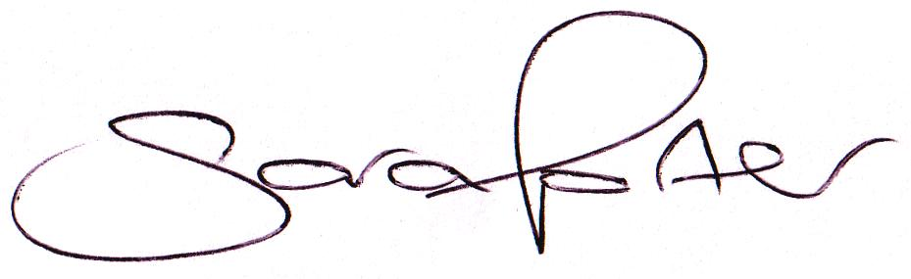Councillors are hereby summoned to attend a Full Council meeting of Watlington Parish Council on Thursday, 25th February 2016 at 7.00pm in the Jubilee Room, Watlington Village Hall, Watlington, for the purpose of transacting the business on the agenda shown below.

Sara Porter (Mrs)
Parish Clerk
18th February 2016

The meeting is open to the press and public. Any parishioner wishing to raise a matter on the agenda should speak when invited by the Chairman during the ‘Public Open Forum’.
AGENDA
1. To receive and accept apologies and reasons for absence
2. To approve the minutes of the previous Council meeting held on Thursday, 14th January 2016 (Items 1/16 - 16/16)
3. To receive declarations of interest for items on the agenda and any requests for dispensation
4. To receive Councillors’ issues and village matters
4.1. To receive Councillors’ questions and/or issues
TO ADJOURN THE MEETING IN ORDER TO ALLOW REPORTS TO BE RECEIVED AND THE PRESS AND/OR MEMBERS OF THE PUBLIC TO ADDRESS THE COUNCIL IN A PUBLIC OPEN FORUM
Reports
County Cllr Brian Long
Borough Cllr Peter Hodson
Public Participation (Maximum 20 minutes – 3 minutes per speaker)
5. To receive Finances and Clerk’s Report
5.1. Clerk’s financial report
5.2. Payment authorisation for pre-authorised payments and approval of pending payments listed below. Any payment requests received after publication of the agenda will be reported at the meeting.
Payee | Net Amount | VAT | Authority | Description | Date Paid
Payments
K&M Lighting Services | £ 125.88 | £ 25.18 | Admin | Street Lighting | 07.01.2016
E-On | £ 647.78 | £ 29.56 | Admin | Street Lighting | 11.01.2016
Maxey Grounds & Co | £ 400.00 | £ - | Admin | Glebe Field Rent | 12.01.2016
Maxey Grounds & Co | £ 600.00 | £ - | Admin | Car Park & VH Rent | 12.01.2016
Glazewing | £ 84.10 | £ 16.82 | Admin | Waste Collection | 21.01.2016
Yve Griffiths | £ 25.00 | £ - | WPC | Minute Taking | 21.01.2016
Anglian Water | £ 19.34 | £ - | Admin | Allotments | 28.01.2016
Sherry Grief | £ 82.50 | £ - | Admin | Litter Picking | 28.01.2016
Clerk January | £ 706.06 | £ - | Admin | Salary | 28.01.2016
 | £ 69.80 | £ - | Admin | Expenses | 28.01.2016
 | £ 1.19 | £ - | Admin | Postage | 28.01.2016
HMRC (Jan) | £ 15.64 | £ - | Admin | Employer Tax & NI | 28.01.2016
Glazewing | £ 24.10 | £ 4.82 | Admin | Waste Collection | 18.02.2016
Watlington Village Hall | £ 15.50 | £ - | Admin | Room Hire | 18.02.2016
K&M Lighting Services | £ 125.88 | £ 25.18 | Admin | Street Lighting | 18.02.2016
Receipts
Allotment Tenant | £ 20.00 | £ - | Admin | Allotment Rent | 12.02.2016
UK Power Refund | £ 43.80 | £ - | Admin |  | 12.02.2016
5.3. To consider and approve the reappointment of John Cross, Internal Auditor, at a cost of £25.00 to audit the 2015/2016 accounts
5.4. To consider and approve contracting the Play Inspection Company to carry out the annual inspection of the Recreation Ground, Stone Close Play Area and Warren Close Play Area at a cost of £62.50 per area (Total £187.50 + VAT – no increase on 2014/2015 charges)
5.5. To consider and approve the purchase of a new 50 litre post mounted litter bin for the Millennium Green (Broxap £49.00 + VAT, Kingfisher Direct £50.99 + VAT, Wybone £60.00 + VAT)
5.6. To approve the annual subscription to the Society of Local Council Clerks (SLCC) at a cost of £74.50 (split equally with Marham Parish Council)
5.7. To consider requests for Grants and Donations - none received
6. To receive Correspondence
6.1. For action:
None
6.2. For information:
BCKL&WN | Watlington Taxbase increased from 777.2 to 777.6. Under this calculation the Band D reduces from £50.26 to £50.24. | 05.02.2016
Watlington Village Hall | Due to EU Referendum Council meeting 23rd June 2016 cancelled and rescheduled 16th June 2016 | 16.02.2016
Grounds Maintenance Contract | Requests issued to CGM Group, Norse Commercial, R G Maintenance Services & Ultimate Land & Gardens – responses by 24th March 2016 – to be approved 7th April 2016 | 16.02.2016
Various | Press releases and circulars | Since last meeting
7. To receive reports/updates on the Recreation Ground/Open Spaces and consider and approve any actions required
7.1. Byelaws and use of open spaces – Update by Vice Chairman
7.1.1. To consider and approve £500.00 + VAT legal fees for the transfer of the plot of land adjacent to the Stone Close Play Area from Winchester Homes to the Parish Council and approve the costs for a new deed
7.1.2. To consider contracting the handyman to erect fencing and kissing gate at the Stone Close play area and supply cement up to a cost of £450.00
7.1.3. To consider obtaining quotations for post and wire fencing for the Warren Close Play Area hedge boundary by the side of the Medical Centre
7.1.4. To consider planting fruit trees in the John Davis Way open space and Millennium Green and discuss renaming the John Davis Way open space in commemoration of the Queen’s 90th birthday
7.2. Community Projects – MUGA project – Update by Chairman
7.3. Handyman – Update by Clerk
7.4. Litter Picker – Update by Clerk
7.5 Voluntary Tree Warden – Update by Vice Chairman
8. To receive reports/updates on Community Matters and consider and approve any actions required
8.1. Village Hall – Update by Vice Chairman
8.2. Allotments – Update by Chairman
8.3. Community Payback – Update by Clerk
8.4. Dog Fouling – Update by Chairman
8.5. Neighbourhood Plan – Report by Cllr Mack
9. To receive reports/updates on Highways & Transport Matters and consider and approve any actions required
9.1. Parish Partnership – 2015/2015 Trod bid – Update by Chairman
9.2. Parish Partnership Scheme 2016/2017 – Bid submitted – Response March 2016
9.3. Train station commuter parking in nearby residential streets
10. To consider Planning Applications and note Planning Decisions from the BCKL&WN
10.1. Planning Applications for consultation:
10.1.1. 15/01306/OM – Storage Land, Station Road – Amendment details for Outline application with some matters reserved for mixed use development comprising 50 no. space car park, 500sq m of B1 use and 9 no. dwellings – No objections to the amendment but the previous Council comments still apply
10.1.2. 15/02051/F – 6 St Peters Road – Single storeyside/rear extension – No objections
10.1.3. 16/00067/F – Alpine, 90 Downham Road – Single storey rear extension – No objections
10.1.4. 16/00071/F – Land On the West Side of Church Road – Installation of additional field floodlights and floodlights for MUGA/FISA – No comment (Declared Pecuniary Interest)
10.1.5. 16/00253/F – 2 Glebe Avenue – Two storey and single storey extensions to dwelling following removal of existing single storey flat roof areas – Comments by 9th March 2016
10.2 Planning Decisions received for information
10.2.1. Planning Inspectorate – Palm Paper Ltd – Palm Paper CCGT Power Station, King’s Lynn – development consent
11. Matters arising and agenda items for the next meeting
12. Date and time of next meeting
12.1. The next meeting of the Council is on Thursday, 7th April 2016 (Including Annual Parish Meeting) at 7.00pm in the Jubilee Hall of the Watlington Village Hall

