WATLINGTON PARISH COUNCIL

Parish Chairman, Mrs Jean Golding
25 Fen Road, Watlington,
King’s Lynn, Norfolk, PE33 0JA
01553 811362

Parish Clerk, Mrs Sara D Porter
The Old School House, High Street,
Stoke Ferry, King’s Lynn, Norfolk, PE33 9SF
01366 502165
watlingtonparish@hotmail.co.uk

watlington.norfolkparishes.gov.uk

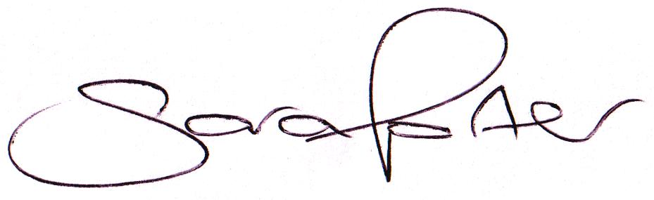Councillors are hereby summoned to attend a Full Council meeting of Watlington Parish Council on Thursday, 14th January 2016 at 7.00pm in the Jubilee Room, Watlington Village Hall, Watlington, for the purpose of transacting the business on the agenda shown below.

Sara Porter (Mrs)
Parish Clerk
7th January 2016

The meeting is open to the press and public. Any parishioner wishing to raise a matter on the agenda should speak when invited by the Chairman during the ‘Public Open Forum’.
AGENDA
1. To receive and accept apologies and reasons for absence
2. To approve the minutes of the previous Council meeting held on Thursday, 26th November 2015 (Items 118/15 - 132/15)
3. To receive declarations of interest for items on the agenda and any requests for dispensation
4. To receive Councillors’ issues and village matters
3.1. To receive Councillors’ questions and/or issues
3.2. To receive report on dog fouling in Fen Road
TO ADJOURN THE MEETING IN ORDER TO ALLOW REPORTS TO BE RECEIVED AND THE PRESS AND/OR MEMBERS OF THE PUBLIC TO ADDRESS THE COUNCIL IN A PUBLIC OPEN FORUM
Reports
County Cllr Brian Long
Borough Cllr Peter Hodson
Public Participation (Maximum 20 minutes – 3 minutes per speaker)
5. To receive Finances and Clerk’s Report
5.1. Clerk’s financial report
5.2. Payment authorisation for pre-authorised payments and approval of pending payments listed below. Any payment requests received after publication of the agenda will be reported at the meeting.
Payee | Net Amount | VAT | Authority | Description | Date Paid
Payments
Tim Wall | £250.00 | £0.00 | Admin | MUGA Project Bid Services | 30.11.2015
Sherry Grief | £82.50 | £0.00 | Admin | Litter Picking Services November | 30.11.2015
Clerk October | £913.98 | £0.00 | Admin | Salary November | 30.11.2015
 | £135.50 | £0.00 | Admin | Clerk Expenses November
 | £1.19 | £0.00 | Admin | Stationery/Equipment
HMRC (Nov) | £64.21 | £0.00 | Admin | Employer Tax & NI | 30.11.2015
Watlington Village Hall | £25.25 | £0.00 | Admin | Room Hire | 08.12.2015
K&M Lighting Services | £125.88 | £25.18 | Admin | Street Lighting Services December | 08.12.2015
2nd Run Hol & Wat Scoup Group | £100.00 | £0.00 | Admin | S137 Donation | 08.12.2015
Winchester Homes Ltd | £225.00 | £0.00 | Admin | Allotment Land Rent | 10.12.2015
Glazewing | £16.90 | £3.38 | Admin | Waste Collection | 17.12.2015
East of the Ouse IDB | £70.00 | £14.00 | Admin | Recreation Ground Hedge Trimming | 17.12.2015
Brenda Leedell | £15.41 | £3.08 | Admin | New Telephone Council Office | 01.01.2016
Hayes & Storr Solicitors | £6.00 | £0.00 | WPC | Stone Close Land Registry Documents | 01.01.2016
Sherry Grief | £82.50 | £0.00 | Admin | Litter Picking Services December | 01.01.2016
Clerk Salary & Expenses | £755.47 | £0.00 | Admin | Salary December | 01.01.2016
 | £59.00 | £0.00 | Admin | Clerk Expenses December
 | £14.15 | £0.00 | Admin | Postage
HMRC (Dec) | £174.63 | £0.00 | Admin | Employer Tax & NI | 01.01.2016
Receipts
Edward Shouldham Refund | £400.00 | £0.00 | Admin | Repayment (Skipper) | 01.12.2015
Wren Refund | £75.90 | £0.00 | WPC | Millennium Green Project | 19.12.2015
5.3. To consider requests for Grants and Donations - none received
6. To receive and consider 2016/2017 draft Budget and approve final Budget
7. To receive and consider 2016/2017 proposed Precept and adopt final Precept
8. To receive Correspondence
8.1. For action:
National Association of Local Councils (NALC) | New audit regime by Sector Led Body – deadline for opting out 31.01.2016 | 24.11.2015
Watlington Fete Working Group | Permission to hold Village Fete on Recreation Ground and Glebe Field | 07.12.2015
8.2. For information:
Came & Company Insurance | Liability Cover for voluntary tree warden | 29.12.2015
Various | Press releases and circulars | Since last meeting
9. To receive reports/updates on the Recreation Ground/Open Spaces and consider and approve any actions required
9.1. Byelaws and use of open spaces – Update by Vice Chairman
9.2. Community Projects – MUGA project – Update by Chairman
9.3. Handyman – Update by Clerk
9.4. Litter Picker – Update by Clerk
9.5 Voluntary Tree Warden – Update by Vice Chairman
10. To receive reports/updates on Community Matters and consider and approve any actions required
10.1. Village Hall – Update by Vice Chairman
10.2. Village Hall Office – Update by Vice Chairman
10.3. Allotments – Update by Chairman
10.4. Community Payback – Update by Clerk
10.5. Neighbourhood Plan – Report by Cllr Mack
11. To receive reports/updates on Highways & Transport Matters and consider and approve any actions required
11.1. Parish Partnership – 2015/2015 Trod bid – Update by Chairman
11.2. Parish Partnership Scheme 2016/2017 – Bid submitted – Response March 2016
12. To consider Planning Applications and note Planning Decisions from the BCKL&WN
12.1. Planning Applications for consultation: None received
12.2 Planning Decisions received for information:
12.2.1. 15/01723/F – Twin Trees, 44 Downham Road – Construction of a new dwelling – Application Permitted (Delegated decision)
13. To receive reports/updates on Leases and consider and approve any actions required
14. Matters arising and agenda items for the next meeting
15. Date and time of next meeting
15.1. The next meeting of the Council is on Thursday, 25th February 2016 at 7.00pm in the Jubilee Hall of the Watlington Village Hall
16. Exclusion of Press and Public – To consider a resolution under the Public Bodies (Admission to meetings) Act 1960 Section 1 that the press and public be excluded from the meeting in order to discuss the following confidential item:
16.1. To consider the Litter Picker’s new agreement

