WATLINGTON PARISH COUNCIL

Parish Chairman, Mrs Jean Golding
25 Fen Road, Watlington,
King’s Lynn, Norfolk, PE33 0JA
01553 811362

Parish Clerk, Mrs Sara D Porter
The Old School House, High Street,
Stoke Ferry, King’s Lynn, Norfolk, PE33 9SF
01366 502165
watlingtonparish@hotmail.co.uk

watlington.norfolkparishes.gov.uk

Councillors are hereby summoned to attend a Full Council meeting of Watlington Parish Council on Thursday, 28th July 2016 at 7.00pm in the Jubilee Room, Watlington Village Hall, Watlington, for the purpose of transacting the business on the agenda shown below.
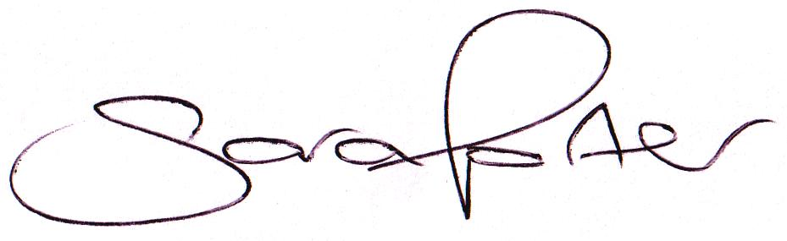

Sara Porter (Mrs)
Parish Clerk
21st July 2016

The meeting is open to the press and public. Any parishioner wishing to raise a matter on the agenda should speak when invited by the Chairman during the ‘Public Open Forum’.
AGENDA
- To receive and accept apologies and reasons for absence
- To approve the minutes of the Council Meeting held on Thursday, 16th June 2016 (Items 60/16 - 72/16)
- To receive declarations of interest for items on the agenda and any requests for dispensation
- To receive Councillors’ issues and village matters
  - To consider the Co-option of applicants for the position of Councillor
  - Railway Station commuter parking in residential areas – Cllr Beeby to report
TO ADJOURN THE MEETING IN ORDER TO ALLOW REPORTS TO BE RECEIVED AND THE PRESS AND/OR MEMBERS OF THE PUBLIC TO ADDRESS THE COUNCIL IN A PUBLIC OPEN FORUM
Reports
County Cllr Brian Long
Borough Cllr Peter Hodson
Public Participation (Maximum 20 minutes – 3 minutes per speaker)
- To receive Finances and Clerk’s Report
  - Clerk’s financial report
  - Payment authorisation for pre-authorised payments and approval of pending payments listed below
Date | Payee | Description | Transaction | Net £ | VAT £ | Gross £ | Receipt £
06.06.2016 | Barclays Bank Plc | Bank Interest | BACS | 0.00 | 0.00 | 0.00 | 12.01
20.06.2016 | Allotment Tenant (Plot 15) | Allotment Rent | Stub 100076 | 0.00 | 0.00 | 0.00 | 40.00
21.06.2016 | Glazewing | Waste Collection May | 102500 | 24.56 | 4.91 | 29.47 | 0.00
21.06.2016 | K&M Lighting Services Ltd | Street Lighting Maintenance Jun | 102501 | 125.88 | 25.18 | 151.06 | 0.00
21.06.2016 | Ultimate Land & Gardens Ltd | Grounds Maintenance 04.06.2016 | 102502 | 206.33 | 41.27 | 247.60 | 0.00
21.06.2016 | AFMGT | S137 Annual Grant | 102503 | 1000.00 | 0.00 | 1000.00 | 0.00
21.06.2016 | General Gardening Services | Station Road Beds Gardening | 102504 | 48.00 | 0.00 | 48.00 | 0.00
21.06.2016 | Allotment Tenant (Plot 5) | Allotment Rent | Stub 100077 | 0.00 | 0.00 | 0.00 | 30.00
22.06.2016 | HMRC | VAT Repayment 2015/2016 | BACS | 0.00 | 0.00 | 0.00 | 2498.53
28.06.2016 | Allotment Tenant (Plot 16) | Allotment Rent | Stub 100078 | 0.00 | 0.00 | 0.00 | 10.00
28.06.2016 | Ultimate Land & Gardens Ltd | Grounds Maintenance 22.06.2016 | 102505 | 206.33 | 41.27 | 247.60 | 0.00
28.06.2016 | Thomas Thorrold (Temp Contract) | Litter Picking June | 102506 | 102.00 | 0.00 | 102.00 | 0.00
28.06.2016 | Clerk Salary | Salary | 102507 | 870.72 | 0.00 | 870.72 | 0.00
28.06.2016 | Clerk Expenses | Expenses | 102507 | 80.60 | 0.00 | 80.60 | 0.00
28.06.2016 | Clerk Litter Bin (Wybone) | Litter Bin Millennium Green | 102507 | 70.84 | 14.17 | 85.01 | 0.00
28.06.2016 | Clerk Postage | Postage | 102507 | 4.20 | 0.00 | 4.20 | 0.00
28.06.2016 | HMRC | Employer PAYE / NI | 102508 | 57.71 | 0.00 | 57.71 | 0.00
28.06.2016 | Ultimate Land & Gardens Ltd | Grounds Maintenance 27.06.2016 | 102509 | 206.33 | 41.27 | 247.60 | 0.00
11.07.2016 | E-On | Street Lighting Apr-Jun | DD | 640.98 | 128.20 | 769.18 | 0.00
19.07.2016 | Cllr B Leedell (DMG Timber) | Timbers Stone Close Play Area | 102510 | 3.75 | 0.75 | 4.50 | 0.00
19.07.2016 | Glazewing | Waste Collection June | 102511 | 24.46 | 4.89 | 29.35 | 0.00
19.07.2016 | Watlington Village Hall | Room Hire 16.06.2016 | 102512 | 15.50 | 0.00 | 15.50 | 0.00
19.07.2016 | K&M Lighting Services Ltd | Street Lighting Maintenance Jul | 102513 | 125.88 | 25.18 | 151.06 | 0.00
19.07.2016 | Kompan Ltd | Stone Close Play Area Fencing | 102514 | 3080.79 | 616.15 | 3696.94 | 0.00
19.07.2016 | Anglian Water Apr-Jul | Allotment Water Supply | 102515 | 47.70 | 0.00 | 47.70 | 0.00
Totals this month |  |  |  | 6942.56 | 943.22 | 7885.78 | 2590.54
  - To consider and receive quotations for the purchasing of new padlocks for the play areas and approve the disbursement (circulated with agenda)
  - To consider purchasing a fan heater for the Council office at a cost of ££9.99 from Argos (circulated with agenda)
5.5. To consider local requests for Grants and Donations: none received
- To receive Correspondence
  - For action: None
  - For information:
BCKL&WN | Devolution Briefing 12.07.2016 | 12.07.2016
Norfolk County Council | Devolution Consultation (08.08.2016-23.08.2016) | By 23.08.2016
BCKL&WN | Local government circulars | No action required
Norfolk ALC | Newsletters | No action required
Various | Varying emails for information purposes (circulated to Councillors) | No action required
- To receive reports/updates on the Recreation Ground/Open Spaces and consider and approve any actions required
  - Byelaws and use of open spaces – Update by Vice Chairman
    - To receive update on the play area signage
  - Community Projects – MUGA project – Update by Chairman
    - To receive the Watlington Football Club’s particulars for potential changing room facilities on the Recreation Ground
  - Play Areas – Report from Play Area Inspections Panel
    - To consider recommendations regarding the Play Area inspections and receive updates
  - Tree Preservation Orders (TPO’s)
    - To receive report from TPO Panel regarding potential TPO applications
  - Handyman – Update by Clerk
  - Litter Picker – Update by Clerk
    - To receive update on temporary 3 month Litter Picker contract
  - Voluntary Tree Warden – Update by Vice Chairman
- To receive reports/updates on Community Matters and consider and approve any actions required
  - Village Hall – Update by Vice Chairman
  - Allotments – Update by Chairman
  - Community Payback – Update by Clerk
  - Neighbourhood Plan – Update by Cllr Beeby and Cllr Bradley
    - To receive debrief from the Councillors who operated the stall at the Watlington Village Fete
  - Speed Watch – Update by Cllr Bradley
- To receive reports/updates on Highways & Transport Matters and consider and approve any actions required
  - Parish Partnership – 2015/2016 Trod bid – Update by Chairman
  - Parish Partnership Scheme 2016/2017 – Update by Chairman
  - Parish Partnership Scheme 2017/2018
    - To consider match funding schemes – Bids to be submitted by 16th December 2016
- To consider Planning Applications and note Planning Decisions from the BCKL&WN
  - Planning Applications for consultation: None received
  - Planning Decisions received for information: None received
- Matters arising and agenda items for the next meeting
- Date and time of next meeting
  - The next meeting of the Council is on Thursday, 1st September 2016 at 7.00pm in the Jubilee Hall of the Watlington Village Hall

