WATLINGTON PARISH COUNCIL

Parish Chairman, Mrs Jean Golding
25 Fen Road, Watlington,
King’s Lynn, Norfolk, PE33 0JA
01553 811362

Parish Clerk, Mrs Sara D Porter
The Old School House, High Street,
Stoke Ferry, King’s Lynn, Norfolk, PE33 9SF
01366 502165
watlingtonparish@hotmail.co.uk

watlington.norfolkparishes.gov.uk

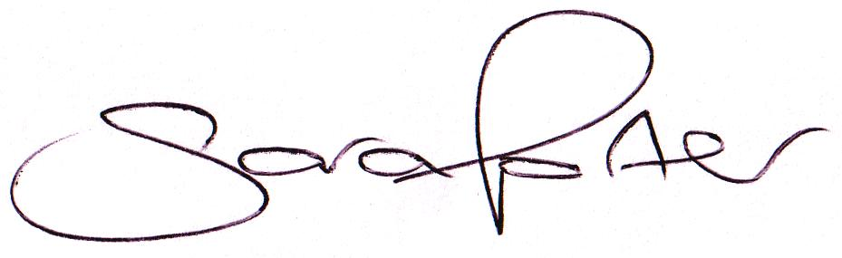Councillors are hereby summoned to attend a Full Council meeting of Watlington Parish Council on Thursday, 30th November 2017 at 7.15pm in the Jubilee Room, Watlington Village Hall, Watlington, for the purpose of transacting the business on the agenda shown below. Councillors and members of the public are invited to arrive at 7.00pm for refreshments.

Sara Porter (Mrs)
Parish Clerk
23rd November 2017

The meeting is open to the press and public. Any parishioner wishing to raise a matter on the agenda should speak when invited by the Chairman during the ‘Public Open Forum’.
AGENDA
- To receive and accept apologies and reasons for absence
- To approve the minutes of the Council Meeting held on Thursday, 19th October 2017 (Items 109/17 – 121/17)
- To receive declarations of interest for items on the agenda and any requests for dispensation
TO ADJOURN THE MEETING IN ORDER TO ALLOW REPORTS TO BE RECEIVED AND THE PRESS AND/OR MEMBERS OF THE PUBLIC TO ADDRESS THE COUNCIL IN A PUBLIC OPEN FORUM
Reports
County Cllr Brian Long
Borough Cllr Peter Hodson
Public Participation (Maximum 20 minutes – 3 minutes per speaker)
- To receive Councillors’ issues and village matters
  - To receive update regarding Casual Vacancies – Clerk to report

- To receive Finances and Clerk’s Report
  - Clerk’s financial report
  - Payment authorisation for pre-authorised payments and pending payments listed below:
Date | Payee | Description | Transaction | Net £ | VAT £ | Gross £ | Receipt £
24.10.2017 | Argos | Laptop Riser | Debit Card | 16.66 | 3.33 | 19.99 | 0.00
26.10.2017 | Barclays Bank Cash Machine | S137 Wreath/MUGA Refreshments | Cash | 30.00 | 0.00 | 30.00 | 0.00
31.10.2017 | Litter Picker | Litter Picking October 2017 | BACS | 195.00 | 0.00 | 195.00 | 0.00
31.10.2017 | Clerk | Salary & Expenses October 2017 | BACS | 987.71 | 0.00 | 987.71 | 0.00
06.11.2017 | PlayInnovation | First Instalment MUGA | BACS | 37,231.20 | 7,446.24 | 44,677.44 | 0.00
06.11.2017 | Watlington Gossip Magazine | MUGA Donation | BACS | 0.00 | 0.00 | 0.00 | 1,000.00
08.11.2017 | Anglian Water | Allotment Water Rates | DD | 132.25 | 0.00 | 132.25 | 0.00
10.11.2017 | HMRC | PAYE NI & Tax October 2017 | BACS | 127.89 | 0.00 | 127.89 | 0.00
16.11.2017 | Post Office | Sports England Application postage | Debit Card | 1.30 | 0.00 | 1.30 | 0.00
16.11.2017 | Mr & Mrs Zipfell | Edward Shouldham Lease | Stub 200007 | 0.00 | 0.00 | 0.00 | 150.00
23.11.2017 | Edward Shouldham Charity A/C | Edward Shouldham Lease Refund | 102556 | 150.00 | 0.00 | 150.00 | 0.00
23.11.2017 | Norfolk Citizens Advice | S137 Donation | 102557 | 20.00 | 0.00 | 20.00 | 0.00
23.11.2017 | Norfolk Accident Rescue Service | S137 Donation | 102558 | 20.00 | 0.00 | 20.00 | 0.00
To be paid | PlayInnovation | Second Instalment MUGA | BACS | 30,000.00 | 6,000.00 | 36,000.00 | 0.00
Totals this month |  |  |  | 68,912.01 | 13,449.57 | 82,361.58 | 1,150.00

  - To consider local requests for Grants and Donations
  - To arrange a meeting date of the Finance Panel to discuss the draft 2018/2019 budget
- To receive general Correspondence
  - For action
  - Late Correspondence
- To receive reports/updates on the Recreation Ground/Open Spaces and consider and approve any actions required
  - Byelaws and use of open spaces
  - Community Projects
    - MUGA project
      - Update on application for approval of Public Works Loan Board loan
      - To receive debrief on the open day event held on Saturday, 11th November 2017
  - Play Areas
    - Issues arising (excluding those recorded on the fortnightly inspection sheets)
  - Environment
    - Environment Panel’s recommendations regarding potential Tree Preservation Orders (TPO) applications
  - Handyman
  - Litter Picker
  - Voluntary Tree Warden
- To receive reports/updates on Community Matters and consider and approve any actions required
  - Village Hall
  - Allotments
  - Community Payback
  - Speed Watch
- To receive reports/updates on Highways & Transport Matters and consider and approve any actions required
  - Parish Partnership Scheme 2017/2018
  - Parish Partnership Scheme 2018/2019 – bids to be submitted by 11th December 2017
    - To discuss and consider the SAM2 bid scheme for submission
  - Footpath between Station Road and Cecil Close
- To consider Planning Applications and note Planning Decisions from the BCKL&WN
  - Planning Applications for consultation:
    - 17/01931/F – North West of 1 Thieves Bridge Road – Removal of condition 3 of planning permission 16/01502/F – comments by 9th November 2017
  - Planning Decisions received for information: none
- Matters arising and agenda items for the next meeting
- Date and time of next meeting
  - The next meeting of the Council is on Thursday, 11th January 2018 at 7.15pm in the Jubilee Hall of the Watlington Village Hall

