WATLINGTON PARISH COUNCIL

Parish Chairman, Mrs Jean Golding
25 Fen Road, Watlington,
King’s Lynn, Norfolk, PE33 0JA
01553 811362

Parish Clerk, Mrs Sara D Porter
The Old School House, High Street,
Stoke Ferry, King’s Lynn, Norfolk, PE33 9SF
01366 502165
watlingtonparish@hotmail.co.uk

watlington.norfolkparishes.gov.uk

Councillors are hereby summoned to attend the a Full Council of Watlington Parish Council on Tuesday, 18th June 2019 at 7.00pm in the Committee Room, Watlington Village Hall, Watlington, for the purpose of transacting the business on the agenda shown below.
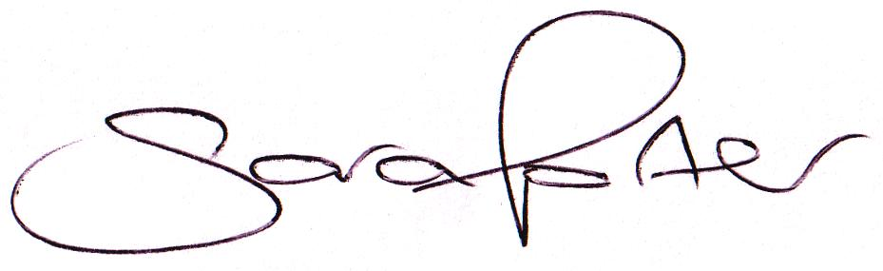

Sara Porter (Mrs)
Parish Clerk
13th June 2019

The meeting is open to the press and public. Any parishioner wishing to raise a matter on the agenda should speak when invited by the Chairman during the ‘Public Open Forum’.

AGENDA
- To receive and accept apologies and reasons for absence
- To receive declarations of interest for items on the agenda and any requests for dispensation
- To approve the minutes of the Annual Meeting held on Tuesday, 7th May 2019 (Items 44/19 - 60/19)
- To review the representatives of Council Panels and outside body representation – deferred from last meeting
4.1. Panels & Responsibilities
4.1.2. Play Area Inspections – Currently Cllrs Golding and Prior and Mr K Leedell (non-voting rights)
4.2. Appointed Representatives to outside bodies
4.2.1. Village Hall – Currently Cllr Leedell
- To receive Councillors’ issues and village matters
5.1. Norfolk Constabulary Community Meeting Thursday, 13th June 2019 – Debrief
TO ADJOURN THE MEETING IN ORDER TO ALLOW REPORTS TO BE RECEIVED AND THE PRESS AND/OR MEMBERS OF THE PUBLIC TO ADDRESS THE COUNCIL IN A PUBLIC OPEN FORUM
Reports
County Cllr Brian Long
Borough Cllr Jim Bhondi
Public Participation (Maximum 20 minutes – 3 minutes per speaker)
- To receive Finances and Clerk’s Report

  - Bank reconciliation (circulated with agenda)
  - To approve the annual insurance renewal premium with Came & Company due 1st August 2019 of £1,753.51 (2018/2019 premium was £1,699.87 – LTA expires 2021)
  - To receive quotations and consider purchasing MICROSOFT Office Home & Business 2019 - Lifetime for 1 user for the new office
  - To consider purchasing 5 x engraved name badges from Ebay at a cost of £5.48 (£0.99 each + P&P £0.53)
  - To consider local Grants and Donations

    - Annual S137 Grant Church (£550.00)
    - Annual S137 Grant Angel Field Millennium Green Trust (£1,000.00)
    - Watlington Village Hall – floor refurbishment
    - Norfolk Accident Rescue Service (NARS) – Countywide
  - To receive and agree finances since last meeting and approve pre-authorised payments and pending disbursements to be made
- Annual Governance for the Accounts 2018/2019

  - To approve the Annual Internal Audit Report 2018/2019 prepared by Mr John Cross and consider recommendations made
  - To approve the Annual Governance Statement 2018/2019 (Section 1 Annual Return)
  - To approve the Accounting Statements 2018/2019 (Section 2 Annual Return)
  - To approve the Notice of Appointment of Date for the Exercise of Electors’ Rights
- To receive and approve the Edward Shouldham Charity Accounts 2018/2019
- To receive general Correspondence
  - For action
    - Local Passenger Benefit Fund (circulated with agenda)
  - Late Correspondence
- To receive reports/updates on the Recreation Ground/Open Spaces and consider and approve any actions required
  - Byelaws and use of open spaces

  - Play Areas
    - Annual Play Area Inspection Reports update and to approve any disbursements for items required (circulated with agenda)
  - Environment
- To receive reports/updates on Community Matters and consider and approve any actions required
  - SAM2 Data
  - Village Hall
  - Fete (Saturday, 15th June 2019) – debrief
  - Allotments
  - Community Payback
- To receive reports/updates on Highways & Transport Matters and consider and approve any actions required
  - Parish Partnership Scheme 2017/2018 – trod
  - Parish Partnership Scheme 2019/2020 (trod John Davis Way to Paige Close and School zig zag lines)
  - Parish Partnership Scheme 2020/2021 – to consider scheme(s) for submission (bids to be submitted by Friday, 6th December 2019)
  - To receive update regarding Public Meeting held 10th January 2019 concerning Railway Station commuter parking
- To consider Planning Applications and note Planning Decisions from the BCKL&WN
  - Planning Applications for consultation
    - 19/00246/NMA_1 – Georgena, 82 Downham Road – NON-MATERIAL AMENDMENT TO PLANNING PERMISSION 19/00246/F: Two storey extension to dwelling – Information only
    - 19/00908/F – 6 Fen Road – Proposed single storey extensions and alterations – comments by 15th June 2019
    - 19/00969/F – 11 Downham Road – Construction of garage to serve dwelling – comments by 27th June 2019

  - Planning Decisions received for information
    - 19/00434/F – 4 Britton Close – Single storey front and two storey side extensions – Application permitted (delegated decision)
    - 19/00170/RMM – PRIVATE Car Park, Watlington Station, Station Road – RESERVED MATTERS: Erection of 9 dwellings, cart lodges, B1 units, bin and cycle storage and car parking spaces (Amended plan) – Application permitted (delegated decision)
    - 19/00693/F – 41 Paige Close – Side extension on existing bungalow – Application permitted (delegated decision)
    - 19/00246/NMA_1 – Georgena, 82 Downham Road – NON-MATERIAL AMENDMENT TO PLANNING PERMISSION 19/00246/f: Two storey extension to dwelling – Application permitted (delegated decision)
  - Late Planning Applications and Decisions received
  - Other Planning Matters
- Matters arising and agenda items for the next meeting
- Date and time of next meeting
  - The next meeting of the Council is on Tuesday, 30th July 2019 at 7.00pm in the Jubilee Hall of the Watlington Village Hall
- Exclusion of Press and Public – To consider a resolution under the Public Bodies (Admission to meetings) Act 1960 Section 1 that the press and public be excluded from the meeting in order to discuss the following confidential item
  - Edward Shouldham Charity Land

