WATLINGTON PARISH COUNCIL
Parish Clerk, Mrs Sara D Porter

The Old School House ~ High Street ~ Stoke Ferry ~ King's Lynn ~ Norfolk ~ PE33 9SF
Phone 01366 502165
clerk@watlington-norfolk-pc.gov.uk
www. watlington-norfolk-pc.gov.uk

Name
Date
Reason for Claim
TRAVEL
Journey From
Journey To
Total Number of Miles
Total Travel Claim @ 0.45p per mile |  |  |  | £
EXPENSES (Receipts must be attached)
Item |  |  | Cost | £
Item |  |  | Cost | £
Item |  |  | Cost | £
Item |  |  | Cost | £
Item |  |  | Cost | £
Item |  |  | Cost | £
Total Expenses Claim |  |  |  | £

TOTAL CLAIM (Travel & Expenses) | £
Bank Account Name
Bank Sort Code
Bank Account Number

Signed | 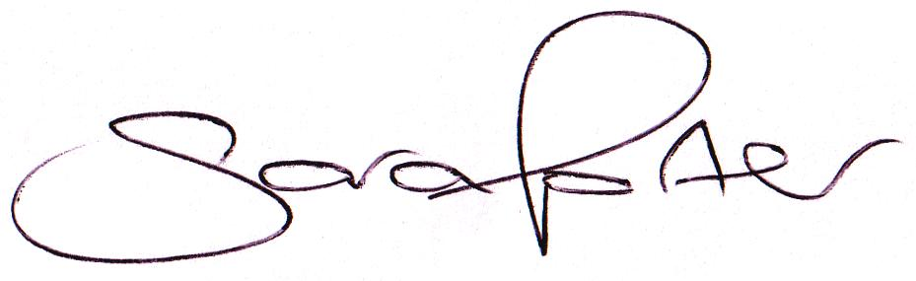

Office Use Only
Net | £
VAT | £

Initialled Clerk |  |  | Date Paid
Initialled Cllr |  |  | Payment Type | BACS

