Watlington Parish Council Office
Risk Assessment October 2015
Reviewed 27th May 2025

The Council leases 42 Church Road, Watlington Village Hall, from the Watlington Village Hall Committee (Landlord). 42 Church Road is the small office room adjacent to the Glebe Field. The Clerk works in the office one day a week on a Thursday from 9.00am – 5.00pm and has carried out a risk assessment based on this working pattern.
The Clerk works alone. The office contains typical office furniture and equipment. There are no kitchen facilities or toilet facilities in the office but facilities are available in the main Village Hall.
An accident book is located in the office and is clearly visible by means of signage.
The Landlord has surveyed the building for the presence of asbestos and carries out an annual fire risk assessment. Matters of concern relating to the Council office are reported to the Landlord immediately.
To identify the hazards the HSE guidelines were assessed and the office examined by the Clerk in October 2015 when the Council office opened. This risk assessment is not exhaustive and will be reviewed on an annual basis in April and/or as soon as matters arise.
Hazard | Who might be harmed and how? | Action being taken | Action by whom?
Trips & slips | Clerk, Councillors and visitors may be injured if they trip over objects or slip on spillages. | - General good housekeeping.  - All areas well lit.  - No trailing leads or cables.  - Interlocking door brace is secured.  - Floor tiles are secure; loose/missing ones immediately reported to Landlord to repair or replace.  - Staff work areas are kept clear.  - No boxes are left in walkways.  - Deliveries are stored immediately.  - Office is cleaned every quarter. | Clerk / Landlord
Manual handling of paper, office equipment, boxes and furniture | Clerk risks injuries or back pain from handling heavy/bulky objects. | - Large document bag used to transport meeting papers and equipment into the Village Hall.  - High shelves for light objects only.  - Large heavy storage boxes to be handled in pairs.  - Storage boxes are not overloaded with excessive weight.  - Clerk to inform Council Chairman and/or Vice Chairman of any pain they may have linked to manual handling. | Clerk and Councillors
Display Screen Equipment | Clerk risks posture problems and pain, discomfort or injuries to their hands and arms from overuse or improper use or poorly designed workstations or work environments. Headaches or sore eyes can also occur if the lighting is poor. | - Training and assessments of workstation to be carried out and any actions dealt with immediately.  - Reassessment to be carried out at any change to work feature including equipment, furniture or the work environment such as lighting.  - Workstation and equipment set to ensure good posture and to avoid glare and reflections on the screen.  - Work planned to include regular breaks or change of activity.  - Lighting and temperature suitably controlled.  - Adjustable blinds at the window to control natural light on screen.  - Noise levels controlled.  - Eye tests provided for those who need them, Council to pay for basic spectacles or portion of cost in other cases.  - Laptop to be used with docking station, screen, keyboard and mouse.  - Clerk to inform Council Chairman and/or Vice Chairman of any pain they may have linked to computer use.  - Window blinds are secure and loose/missing ones reported to Landlord to repair or replace ASAP. | Clerk / Landlord
Refreshment Facilities | Members of public and children risk being scalded. Clerk may feel weak without refreshments and food. | - Kettles with boiling water to be kept out of reach from members of the public and children.  - Refreshments and food purchased by the Clerk for consumption throughout the working day. | Clerk and Councillors
Toilet Facilities | Clerk risks wetting him/herself. The office will be unattended and equipment unlawfully taken. | - Keys to the main Village Hall are available for the Clerk’s use.  - Care must be taken during inclement weather to avoid slips and falls. The office must be locked when the Clerk leaves it unattended.  - Landlord to grit the walkway during snowy and icy conditions. | Clerk / Landlord
Working at height | Clerk risks falling from any height causing bruising and fractures. | - Clerk stands on table to access high shelves.  - External window cleaned using an appropriate stepladder and Clerk shown how to use it safely. | Clerk
Stress | Clerk could be affected by factors such as lack of control, bullying, not knowing their role. | - Clerk and Councillors understand what their duties and responsibilities are.  - Clerk can talk to the Council Chairman and/or Vice Chairman on a no-blame basis if they are feeling unwell or ill at ease because of work.  - The Council has a ‘No Bullying’ policy. | Clerk and Councillors
Working at height | Clerk risks falling from any height causing bruising and fractures. | - High shelves accessed using an appropriate stepladder and Clerk shown how to use it safely.  - External window cleaned using an appropriate stepladder. | Clerk
Electrical | Clerk risks getting an electrical shock or burn from using faulty electrical equipment. Electrical faults can also lead to fires. | - Clerk trained to spot and report any defective plugs, discoloured sockets or damaged cables and equipment.  - Defective equipment is taken out of use safely and promptly.  - Annual PAT tests carried out by qualified contractor.  - Laminator to be kept out of reach of members of public and children whilst warming up and cooling down.  - Laptop, photocopier and wall heater to be switched off at the mains prior to leaving the office. | Clerk and Councillors
Lone Working | Clerk could suffer injury or ill health whilst working alone in the office. | - Clerk displays contact details of Councillors on notice board in case of emergency.  - If the Clerk feels ill at ease by a member of public or a member of public becomes aggressive, the Clerk will press the SOS panic alarm button and attempt to leave the office safely. | Clerk
Fire | Clerk risks getting trapped and could suffer serious and/or fatal injuries from smoke inhalation/burns. | - Landlord to carry out annual fire risk assessment and provide Council with a copy of the report.  - Landlord ensures the actions identified by the fire risk assessor are done. | Landlord

Assessment Review Dates | By Whom | What further action is required? | What is the completion date?
May Annually | Clerk / Council | None | May Annually
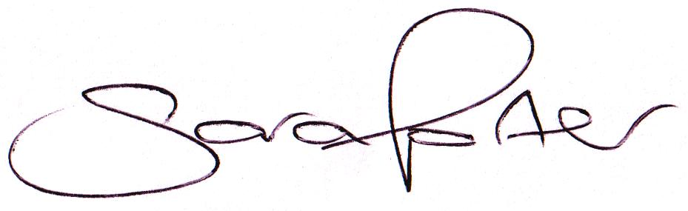

Mrs Sara D Porter
Parish Clerk & Responsible Financial Officer, Watlington Parish Council

